**AIM Insertion Sort, Selection Sort and Bubble Sort**

Mayank Gupta 20BCE1538

#include <iostream>

using namespace std;

void swap(int *arr, int n,int &x,int &y){ int temp=y;

y=x; x=temp;

cout<<x<<" is swapped with "<<y<<endl; for(int i=0;i<n;i++){

cout<<arr[i]<<" ";

}

cout<<endl;

}

void insertionSort(int *arr, int n, int s){ int key,j;

for(int i=1;i<n;i++){ key = arr[i];

j=i;

for(int i=0;i<n;i++){ cout<<arr[i]<<" ";

}

cout<<endl;

cout<<"-> the key taken is "<<key<<endl; while(j>0 && arr[j-1]>key){

cout<<"Right shift "<<arr[j-1]<<" by 1 posn"<<endl; arr[j]=arr[j-1];

j--;

}

cout<<"place the key at the posn of "<<arr[j]<<endl; arr[j]=key;

}

}

void bubbleSort(int *arr, int n){ for(int i=0;i<n;i++){

for(int j=0;j<n-i-1;j++){ if(arr[j]>arr[j+1]){

swap(arr,n,arr[j],arr[j+1]);

}

}

}

}

void display(int *arr, int n){ cout<<"Final Correct Output"<<": "; for(int i=0;i<n;i++){

cout<<arr[i]<<" ";

}

cout<<endl;

}

//11 10 7 9 '5' 6 4 8

void selectionSort(int arr[],int n){ int int_min;

for(int i=0;i<n-1;i++){ int index=0; int_min=999; for(int j=i;j<n;j++){

if(arr[j]<int_min){ int_min=arr[j]; index=j;

}

}

swap(arr,n,arr[index],arr[i]);

}

}

int main()

{

int n; cin>>n; int arr[n];

for(int i=0;i<n;i++){ cin>>arr[i];

}

int arr1[n];

for(int i=0;i<n;i++){ arr1[i]=arr[i];

}

int s=0; //no. of swaps

cout<<"Bubble sort"<<endl; bubbleSort(arr1,n); display(arr1,n);

for(int i=0;i<n;i++){ arr1[i]=arr[i];

}

cout<<"Insertion sort"<<endl; insertionSort(arr1,n,s); display(arr1,n);

for(int i=0;i<n;i++){ arr1[i]=arr[i];

}

cout<<"Selection sort"<<endl; selectionSort(arr1,n); display(arr1,n);

//cout<<"no. of swaps" << s;

return 0;

}

***Output***

# Bubble Sort Output

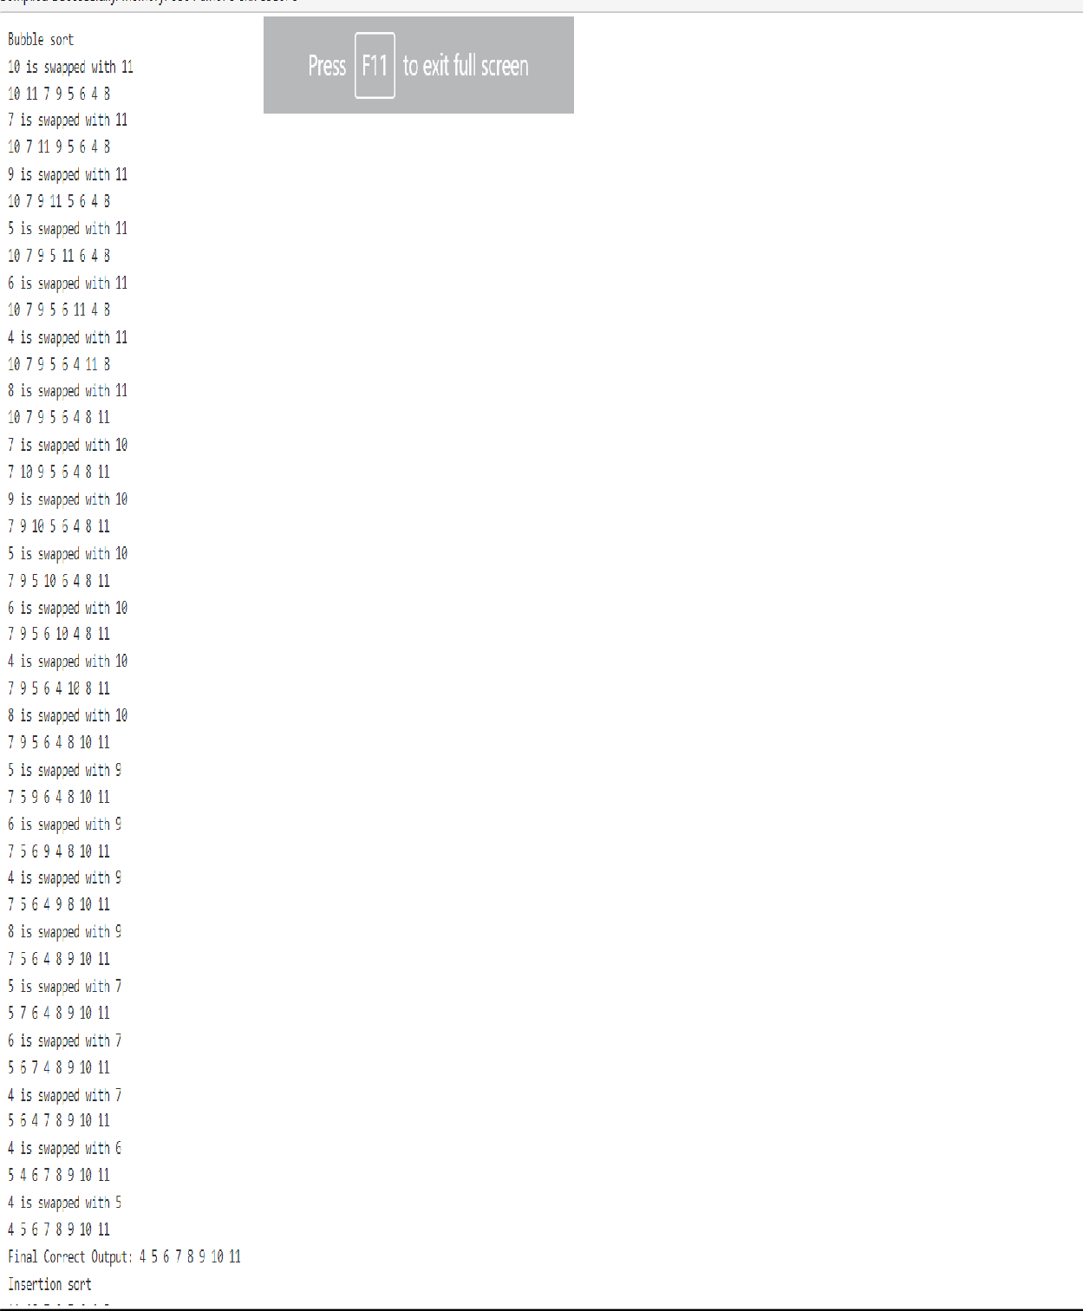

* **Insertion Sort Output**

• 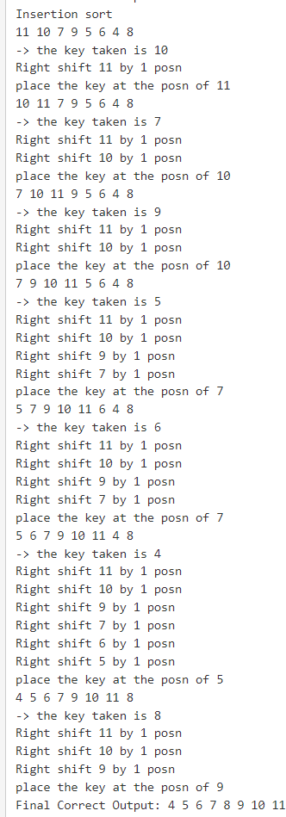

# Selection Sort

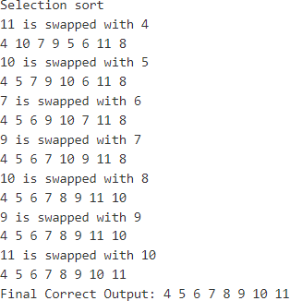

**ALGO FOR INSERTION SORT**

Algorithm

To sort an array of size n in ascending order:

1: Iterate from arr[1] to arr[n] over the array.

2: Compare the current element (key) to its predecessor.

3: If the key element is smaller than its predecessor, compare it to the elements before. Move the greater elements one position up to make space for the swapped element.

**ALGO FOR BUBBLE SORT**

We assume list is an array of n elements. We further assume that swap function swaps the values of the given array elements.

begin BubbleSort(list)

for all elements of list

if list[i] > list[i+1]

swap(list[i], list[i+1])

end if

end for

return list

end BubbleSort

**ALGO FOR SELECTION SORT**

Step 1 − Set MIN to location 0

Step 2 − Search the minimum element in the list

Step 3 − Swap with value at location MIN

Step 4 − Increment MIN to point to next element

Step 5 − Repeat until list is sorted